Mass Timber Building Material

Name
Course
Institution
Date

Mass Timber Building Material

Introduction
In the housing sector in United States, wood as a building material is equivalent to concrete. The term mass timber building refers to structures made up of a vast amount of composite material. It is a style of construction material that uses broad solid timber panels for the walls, floors, and roof. As opposed to standard concrete and steel structures, mass timber goods provide many benefits, including bigger carbon capture, enhanced aesthetics, superior earthquake resistance, and better environmental efficiency. Because of its environmental protection, structural rigidity, and renewability, timber is recognized as an encouraged building material. Timber has been used for domestic, commercial, educational, and industrial building in many areas of the world. The graph below illustrates the number of mass timber constructions that have been built and will be built per year in the United States from 2014 to 2034.
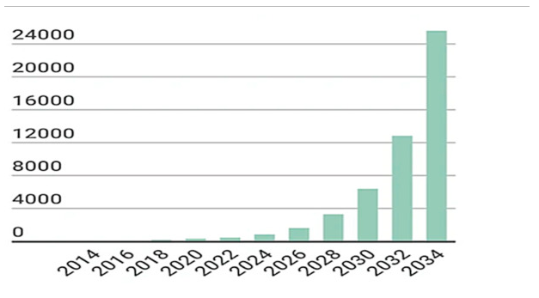
Source: (Ahmed & Arocho, 2020)

Mass timber as an innovative building material
Analyzing the demand opportunity is an essential aspect of introducing a new material. In comparison to other technological aspects of this product, this field has gained comparatively little attention in the US construction industry. The understanding, knowledge, and encouragement of business professionals to embrace a new material will all have a direct effect on the product's performance. In the face of accelerated urbanization and the tremendous need for shelter and housing, it is critical to use construction materials that have a smaller global warming effect than conventional high-energy-intensive materials. The low labor input required by the timber construction method helps to ease the issue of a restricted number of available workers in high-demand production areas. Mass timber plays an advanced part in attaining sustainable sustainability by combining the wood-based system with the town-built climate.

Economic viability and environmental impact
The financial viability of the commodity is a significant factor for assessing the profitability of mass timber building. While the majority of research indicate that mass timber buildings are more costly to construct than conventional steel and concrete frameworks, some studies have found mass timber to be a less expensive choice. Change orders (CO) are an unavoidable phenomenon in building programs, arising mainly during the construction process. Change orders are typically used to address scope of job shifts, material sizes, specification faults, and unit rate changes. The cost difference between wood and other construction alternatives such as steel and concrete are comparable (Ahmed & Arocho, 2020).

Conclusions and suggestions
This analysis focuses on calculating the expense of a mass timber building project and compared it to the modeled cost of a comparable building built with concrete. According to the results of the cost report, the building cost of a mass timber construction is 6.43 percent higher than the exhibited concrete alternative, which backs up previous research that found timber construction costs to be 2–6% higher than conventional concrete and steel construction (Ahmed & Arocho, 2020). The analysis divided all building practices into 17 different groups and found that the expense of engineered timber is the key cause of cost increases. The timber structure's installation cost was also found to be reasonably high. The graph below illustrates a noteworthy difference amid the budgeted and the actual cost of the projects from wood and concrete.
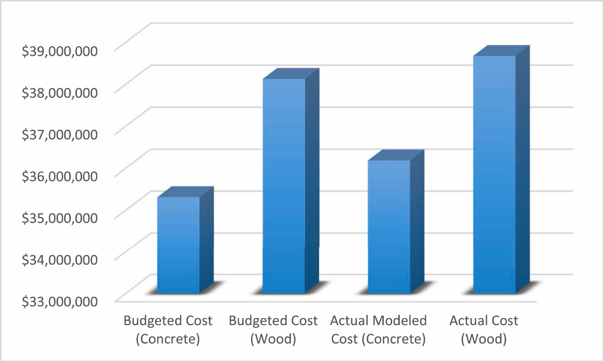
Source: (Ahmed & Arocho, 2021)
The research established a variety of quantitative and qualitative methods to lowering the cost of mass timber construction. The cost of concocted wood is very high, according to this report, which is the main challenge of mass timber production. To maximize the economic viability of mass timber building programs, the cost of engineered wood must be reduced. To reduce the cost of project hiring, equipment service must be streamlined to reduce installation costs, and a skilled workforce specialist in timber construction must be developed. The expense of millwork must be minimized as well. Finally, the number of mass timber processing plants in the United States must be expanded in order to reduce the cost of shipping for prefabricated timber panels. Since the majority of production plants are now situated in the Pacific Northwest area of the nation, transportation costs will skyrocket if a plant were to be built elsewhere. More mass timber buildings would mitigate insurance and city authority uncertainties, as well as eventually could mass timber building preparation costs.

References
Ahmed, S., & Arocho, I. (2020). Mass timber building material in the US construction industry: Determining the existing awareness level, construction-related challenges, and recommendations to increase its current acceptance level. Cleaner Engineering and Technology, 1, 100007.
Ahmed, S., & Arocho, I. (2021). Analysis of cost comparison and effects of change orders during construction: Study of a mass timber and a concrete building project. Journal of Building Engineering, 33, 101856.

